Title: Pirate Yuna Bot

Team ID: P11-1
Team Members: Jerome Goh, Ang Jin Heng, Brendan Tjung, Christopher Jeremy & Ryan Ang
Student ID: 2401012, 2400937, 2401765, 2403304, 2400522
Student Email: 2401012@sit.singaporetech.edu.sg, 2400937@sit.singaporetech.edu.sg, 2401765@sit.singaporetech.edu.sg, 2403304@sit.singaporetech.edu.sg, 2400522@sit.singaporetech.edu.sg

Abstract:
In this project, our group will design a chatbot with a user interface that employs various APIs for text and voice interactions. We will be utilising OpenAI’s API and any other suitable APIs for other integration processes, and voice. This project will allow us to gain an understanding of API Integration. We expect a user-friendly interface that enables us to enter text, detect the user's voice, and convert it into text to interact with an AI. The data that we will be using is the data from OpenAI and our input data.

Introduction:
Inspired by the advancements in Artificial Intelligence and the increasing use of chatbots to assist students and others in acquiring knowledge, our team set out to create an interactive chatbot with a unique personality. The team aimed to design a bot that provides valuable information and engages and entertains users with its distinct conversational style. To achieve this, we divided the development tasks among team members, allowing each person to focus on specific features. In weekly meetings, we then collaborated to integrate our contributions and refine the chatbot's overall functionality.

Methods:
Our team started the project by getting the chatbot’s foundation done by installing all the libraries needed and setting up basic chatbot implementation. The initial foundation of the chatbot was to have a Graphical User Interface (GUI) platform to enter input and receive a response output from ChatGPT, the AI of our choice. After the foundations of the project were done, we further split up to work on the GUI and the speech recognition features which are features that we wanted to implement into our project. We did our research and tried to implement the programme ourselves beforehand and after we would come together to see which codes would work before coming together and editing the usable codes. Soon after, we worked on creating our 2D modelling, Weather API, and SQLite database. After implementing these three functions, we focused on adding personality to our chatbot, resulting in our chatbot with a pirate-like personality.

Results and insights:

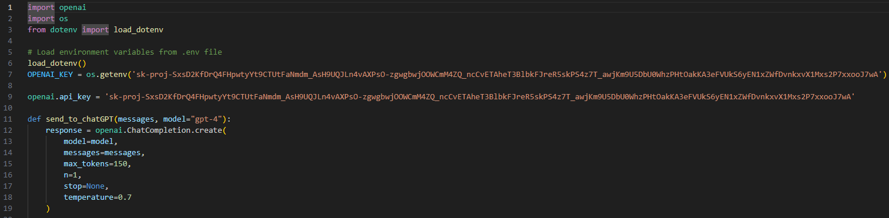
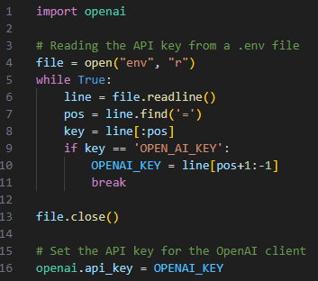
Figure 1 (Env File) Figure 2 (API Key in open)

When our team first created our OpenAI chatbot, our API keys were in the main source folder (Fig 2) which is not a safe approach and can cause potential risks in future. We discussed and concluded by making an env file (Fig 1) and reading the API keys from the file.
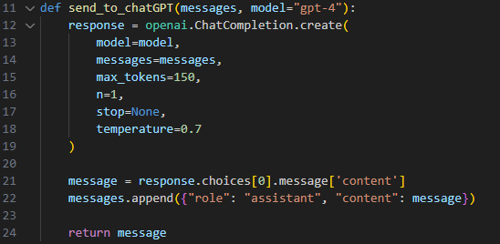
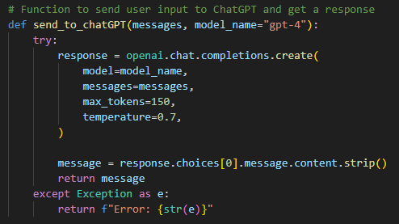
Figure 3 (Old OpenAI Code) Figure 4 (New OpenAI Code)

Our team could not use the latest version of GPT and was using GPT 0.28. ‘openai.ChatCompletion.create()’ (Fig 3) is a legacy code and it does not let us use the latest version of OpenAI, thus we have to use the updated code ‘openai.chat.completion.create()’ (Fig 4) which allows us to use the latest version of OpenAI.

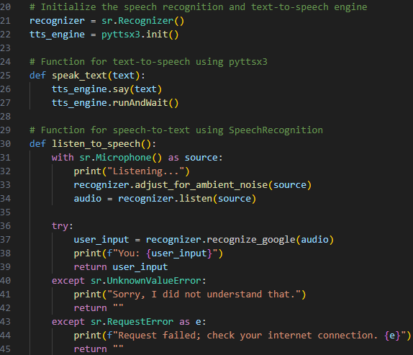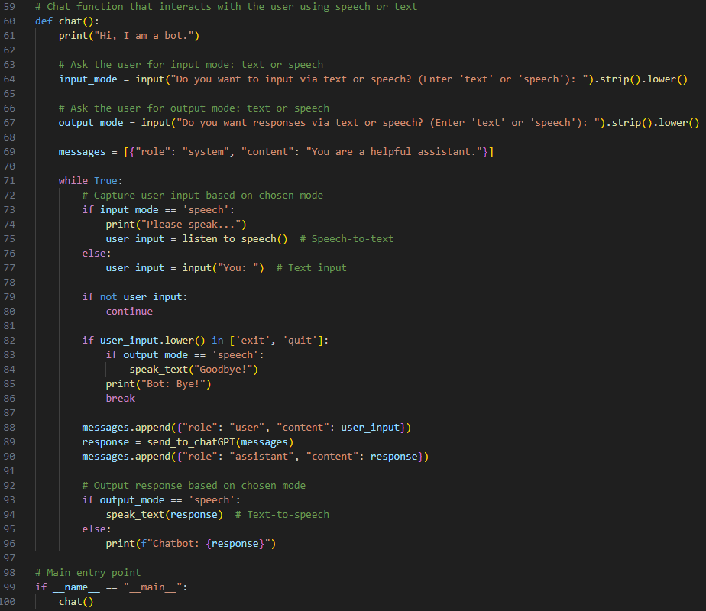
Figure 5 (Function Figure 6 (User input for speech/text config)
For text to speech & speech
to text)

After setting up OpenAI, our next step was to allow the user to have a text-to-speech / speech-to-text output. Before that, there are three libraries we need to install which are SpeechRecognition, pyttsx3 & pyaudio. After that, we created two functions (Fig 5) ‘speak_text(text)’, which uses pyttsx3, converts the text to speech and outputs the chatbot’s response. The other function ‘listen_to_speech()’ uses the speech recognition library and captures the speech from the user's microphone converting it into text with Google’s Speech Recognition API. The remainder of the code (Fig 6) enables the user to choose how they want to input and receive the responses from the chatbot via text/speech.

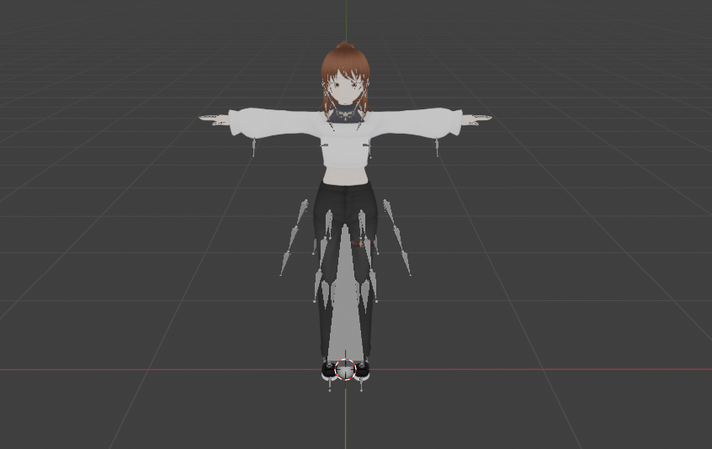
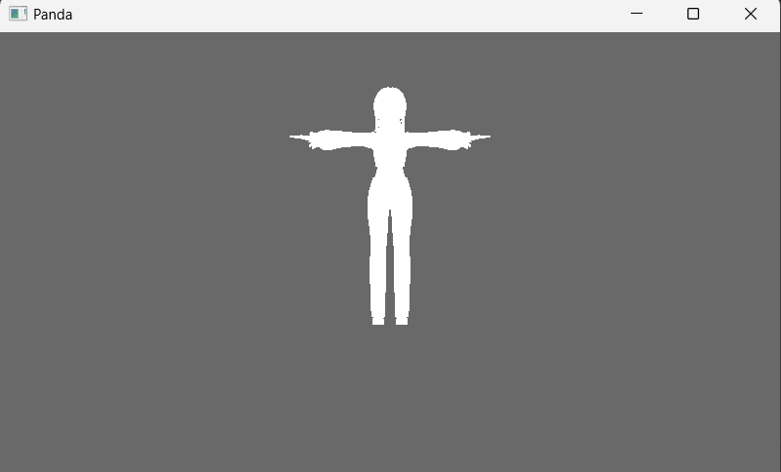
Figure 7 (Panda3D model render output) Figure 8 (Supposed Model Output)

For the 3D modelling, our team attempted to use panda3D to render. However, due to the limitations of panda3D and tkinter, it did not successfully integrate the 3D model into the UI as intended. When the 3d model got rendered out UI was unable to pop out and the colour of the model was also not reflected on the model(as shown in figures 7 and 8). Other factors, like time limitation, and researching the different 3D model rendering ways, we found out that rather than using Tkinter, we could opt out of using Pygame as our UI interface which is more versatile in allowing us to integrate a moving 3D model while having a UI interface.

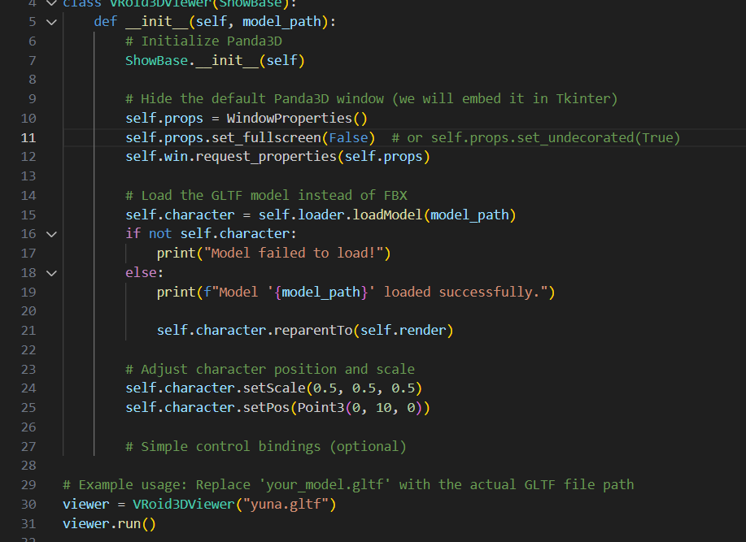
Figure 9 (Setting up Panda3D for 3D rendering) Figure 10 (Importing panda)

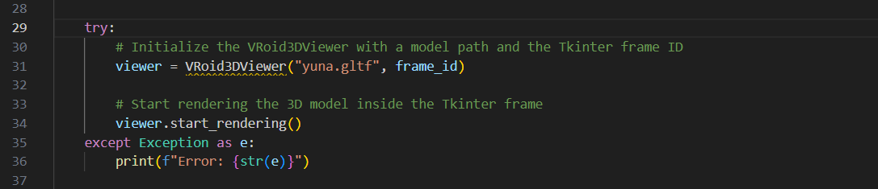
Figure 11: (Trying to get 3d model to render inside the tkinter frame within the GUI module)

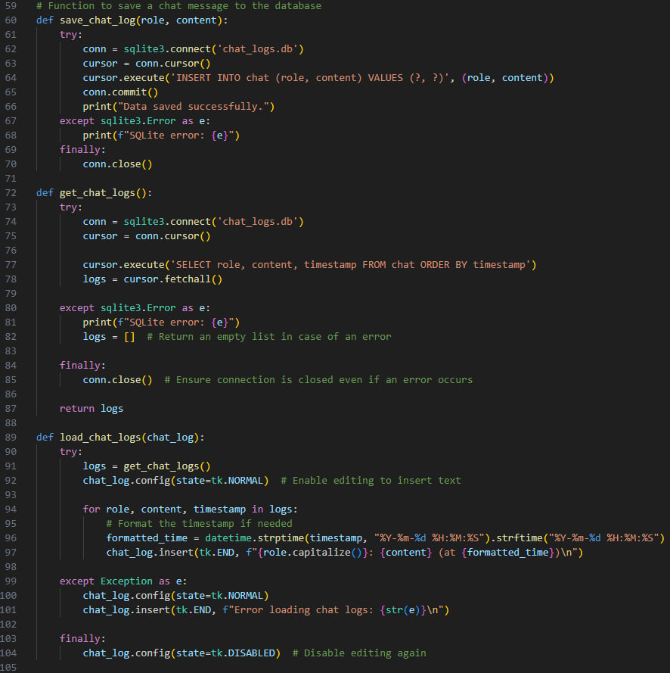
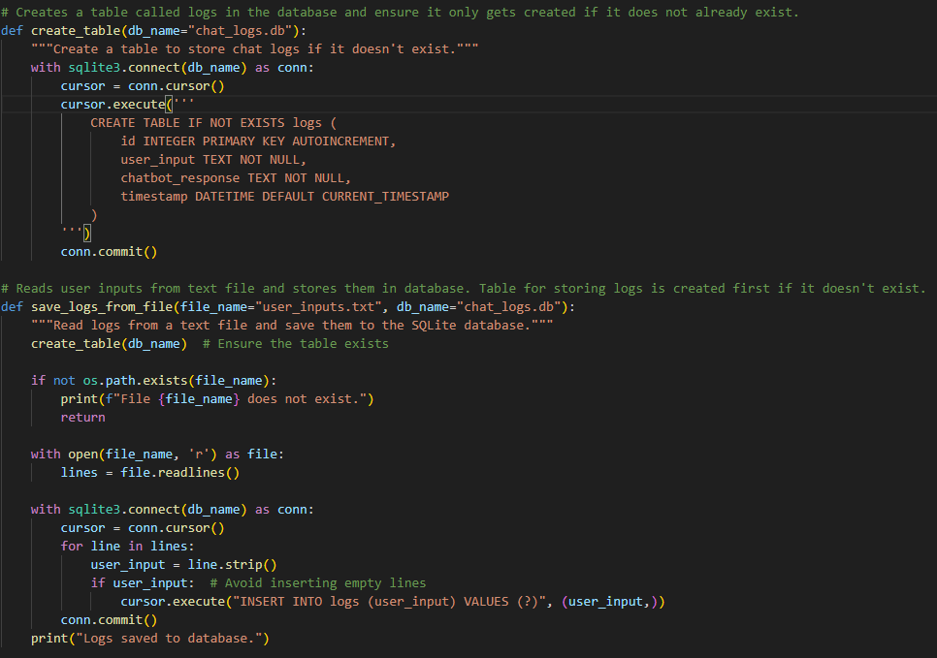
Figure 12 (Saving directly) Figure 13 (Saving from textfile)

Our database was not saving any input or response when we tried to save it directly in string format as shown in Fig 12. We decided to try another method of saving the inputs and responses into a text file by reading it and saving it into our database as shown in Fig 13. It is not the most convenient way as it takes a longer route and requires more time. Despite trying different codes, we were also unable to change the saved timestamp in the SQLite database to save in UTC+8 instead of GMT. We were also unable to save the response when we asked the Chatbot for the weather.

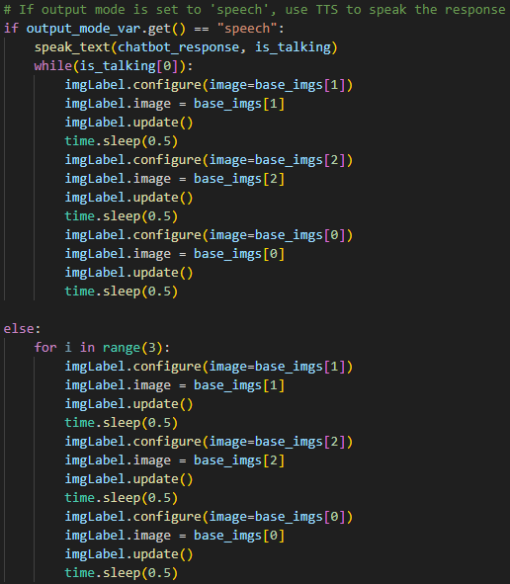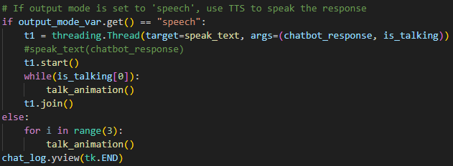
Figure 14 (Animating after speech) Figure 15 (Using thread)

Our team attempted to make a 2D character for the chatbot through animation, but the animation was running into this issue while the output was being given the chatbot only played after it. This is due to how Python executes the code where it will execute code line by line shown in Fig 14, so we decided to use threading. Threading helps to run codes concurrently as it will run back and forth between the two codes as shown in Fig 15, this will allow the animation to play as the output is being given.

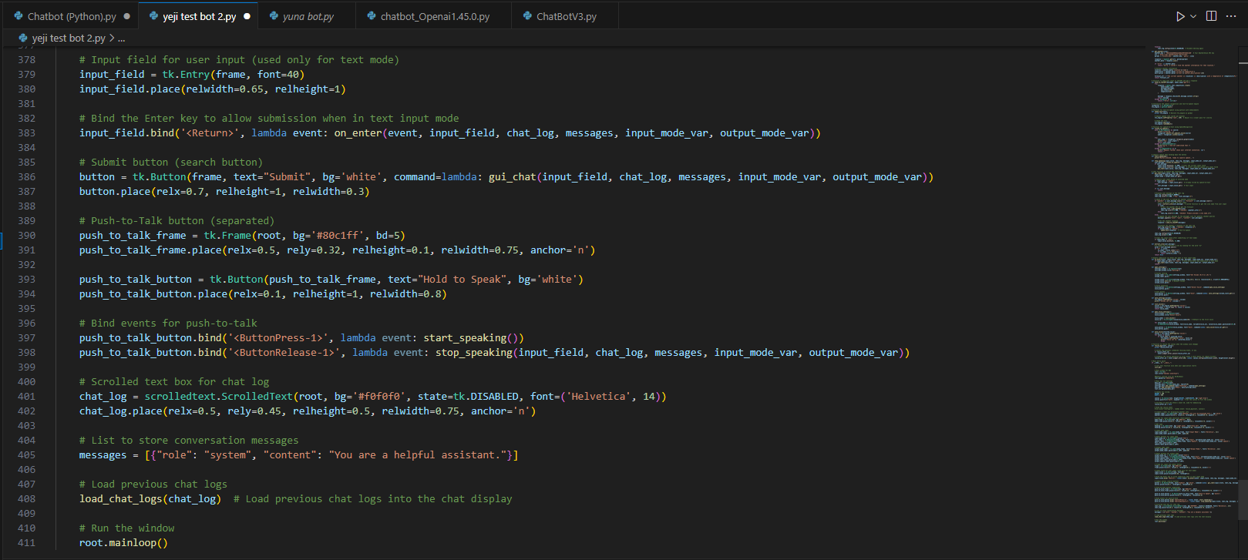
Figure 16 (Codes being 400+ lines)

Our team failed to consider a factor when we began the project and placed all the codes together in one Python file resulting in over 400 lines of code (Fig 16) making it troublesome to debug and troubleshoot. We then had to spend more time editing our codes into different modules to improve the readability, doing so enables an easier time for troubleshooting.

Figure 17 (Functions for settings.py & calling in main)
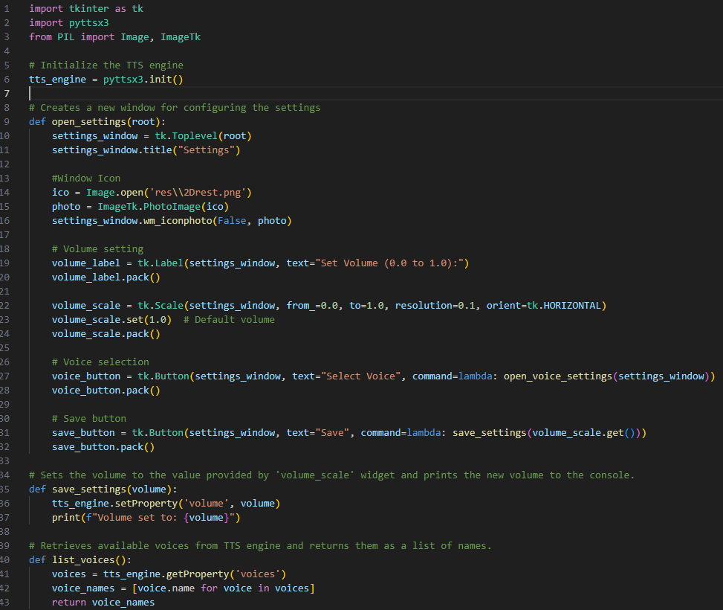
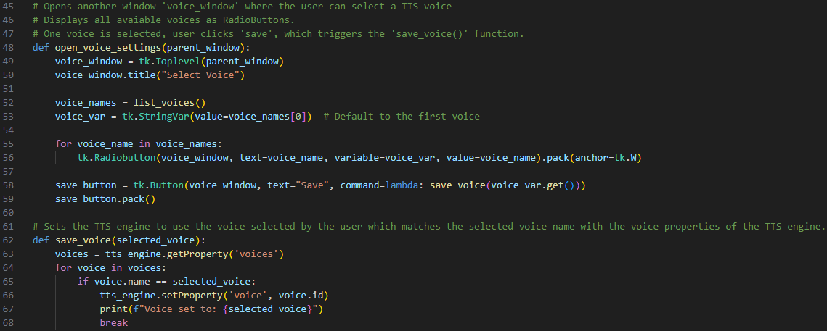

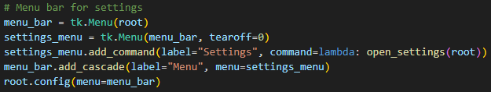

Our team wanted the user to have more options with the chatbot. We used Tkinter to create a menu bar (Fig 17) for the user to configure settings like volume and voice selection. In Figure X, the first function ‘open_settings’ opens a new window for the user to have a volume slider from 0.0 to 1.0 and a select voice button. The functions ‘save_settings’ and ‘save_voice’ enable the user to set the volume based on the slider value, printing it out and text-to-speech(TTS) engine voice based on their selection respectively. The last function ‘open_voice_settings’ opens a window where the user can select up to three voices (in radio buttons) and save them. The last section of the code adds a menu bar to the main window (root) with a ‘settings’ option.

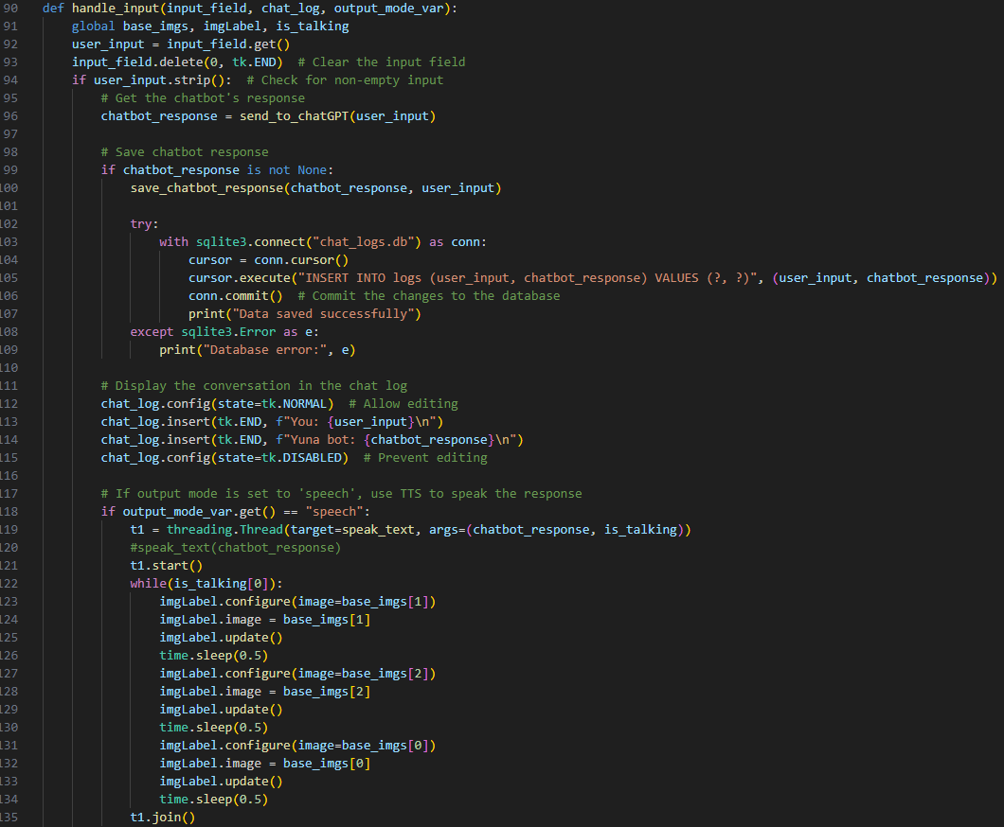
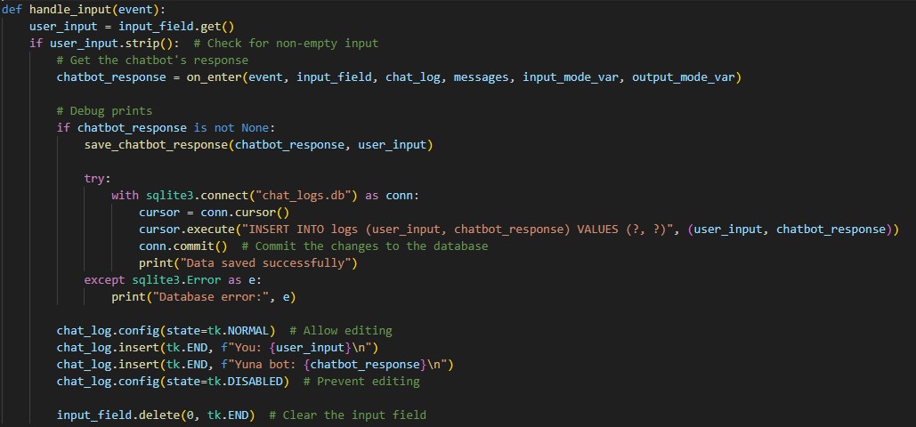

Figure 18 (Old handle_input)
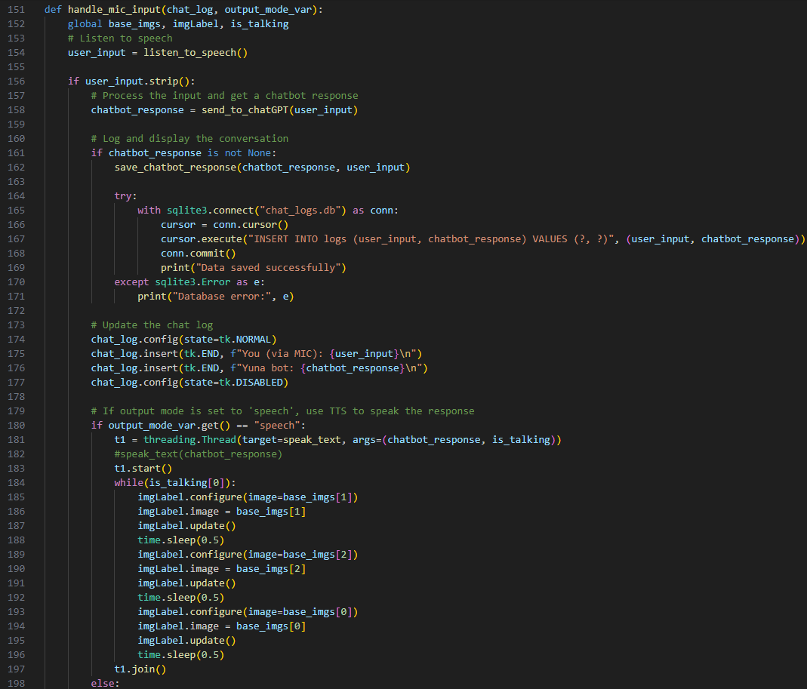

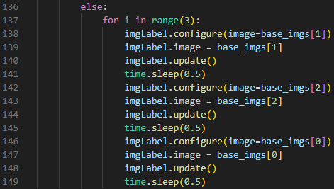

Figure 19 (New handle_input)

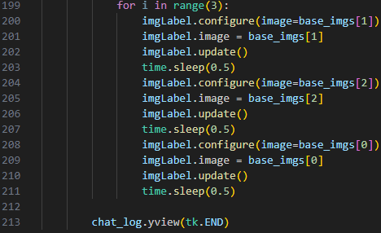
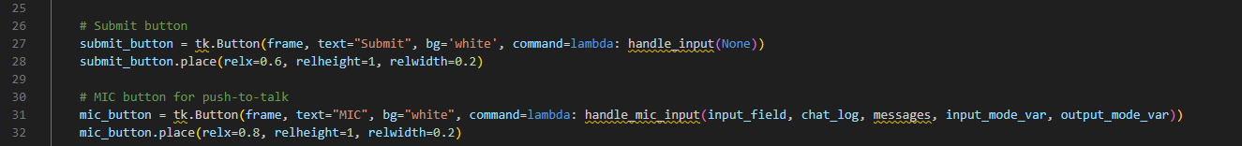

Figure 20 (handle_mic_input) Figure 21 (Updated setup_gui_components in
gui.py)

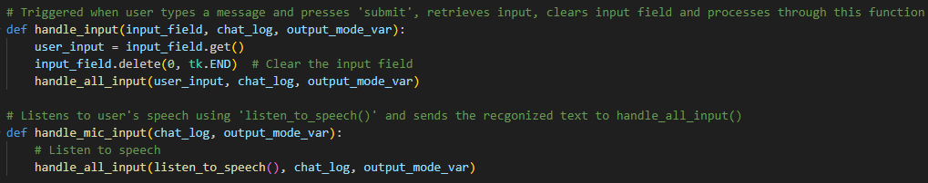

Figure 22 (Revised handle_mic_input & handle_input)

When moving to the module, all the buttons in Tinker stopped responding
In our old ‘gui.py’, we did not allow our submit and mic button to trigger any response to ChatGPT. In the updated code (Figure 21), we added the lambda function to our GUI component. This allows the submit and mic buttons to be activated upon being pressed. For easier management of our input handling, we introduce a new function called handle mic input (Figure 20). This ensures that both the submit and mic buttons are bound to their respective handlers. After looking through both handle input and handle mic input, we discovered that we could merge them into one (Fig 22). Thus, reducing the number of lines of code. Ultimately. The code is easier to debug when any input buttons are not working.

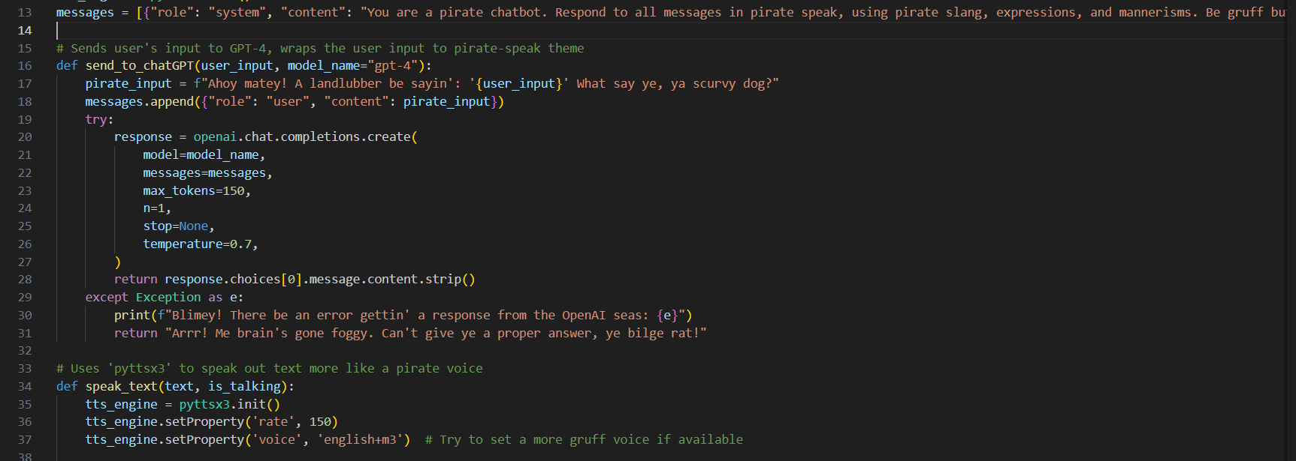
Figure 22 (chatbot.py personality modifier)

Personalisation of the chatbot had to be done via pre-prompting the input before the user submitted it. The initial implementation of personalisation was hard coded to handle exception cases, rather than modifying the chatbot. This, however, didn’t fully convey what our team aims to achieve. To give the AI personality, we instructed the Large Language Model (LLM) to play a role (in this case, a pirate). To do so, we had to append instructions to OpenAI so that it understands its role. This will modify the LLM’s behaviour to the desired personality. Additionally, we updated the text-to-speech function (Fig 22), to align more with the desired personality of the chatbot.

Conclusion:
Our chatbot can give adequate replies based on the database by ChatGPT and can pull weather data from the weather API. Our chatbot also comes with text-to-speech and speech-to-text features and lets the user choose between the two features. Users can look back at their chat history with the chatbot as the conversations are saved in a database. Users can choose between the three voices implemented into the chatbot. In the future, our chatbot will become more interactive by having more personalities. Machine learning can be implemented to improve our chatbot. We can also modify it to integrate software that can be used to do simple tasks for a smart home like turning on house appliances, daily news updates and even daily appointment reminders.

References
Bricot, J. (n.d.). python-dotenv (Version 1.0.0) [Software]. https://github.com/theskumar/python-dotenv
ChatGPT. (n.d.). https://chatgpt.com/
ChatGPT Explained. (2023, March 1). [Video]. YouTube. https://www.youtube.com/watch?v=BEw5EFqCCEI
Clark, A., Geisler, C., & Contributors. (n.d.). Pillow (Version 9.1.0) [Software]. Python Imaging Library (PIL) Fork. https://python-pillow.org/
FreeCodeCamp.org. (2022, February 15). [Video]. YouTube. https://www.youtube.com/watch?v=Kn70Q-pgp1o
Hipp, D. R. (n.d.). SQLite (Version 3.40) [Software]. SQLite. https://sqlite.org
Kore.ai. (2021, November 15). https://blog.kore.ai/8-creative-ways-to-make-your-chatbot-stand-out-from-the-crowd#:~:text=Give%20a%20Name%20and%20Avatar&text=If%20they%20are%20programmed%20to,catchy%20to%20the%20normal%20audience
OpenAI. (n.d.). OpenAI Python client library (Version 0.10.2) [Software]. https://github.com/openai/openai-python
OpenAI. (n.d.). https://platform.openai.com/docs/overview
OpenAI Community. (2023, March 10). [Discussion post]. https://community.openai.com/t/typeerror-missing-required-arguments-expected-either-messages-and-model-or-messages-model-and-stream-arguments-to-be-given/601646/3
Pixiv. (n.d.). https://vroid.com/en/studio
Python Software Foundation. (n.d.). Tkinter (Version 8.6) [Software]. https://docs.python.org/3/library/tkinter.html
TutorialsPoint. (n.d.). https://www.tutorialspoint.com/python/python_gui_programming.htm
W3Schools. (n.d.). https://www.w3schools.com/python/
HaruKitsune Studios. (2022, June 30). [Video]. YouTube. https://www.youtube.com/watch?v=x_gZYZ59cys

Appendix:
Due to our team’s inexperience, our codes were not future-proofed as we did not use modules. This resulted in us having almost 400 lines which was troublesome and ineffective to process when debugging. We had to spend time writing the codes into the different modules and cut down on repeated codes in the modules to reduce it’s size. 2D/3D modelling took longer to implement and we changed to 2D animation due to the limitation of the Tkinter function and using threading to animate it while the output is being given. SQLite database could only save timestamps in GMT despite trying different codes to save the timestamp in UTC+8.

How we used ChatGPT:
When we encountered issues that we could not resolve or debug, we used ChatGPT to try to debug our codes. Chatgpt was mostly able to debug our codes, point out the issues we were facing, and provide us with a better way to implement the features we wanted to use. It also explained how the codes worked and what was causing the issues that we initially encountered.

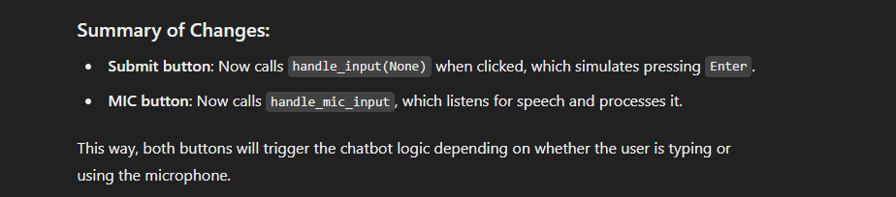

ChatGPT's assistance helped our team debug the issue with the buttons ‘breaking’ and explained how to fix it accurately. After editing it based on ChatGPT's suggestion, we figured out a way to simplify the code (Fig 22). While it could help us identify and solve the error we were facing, it could not generate the most optimal solution. Ultimately, we still need to read and understand how the code runs to help better optimise the code overall.

